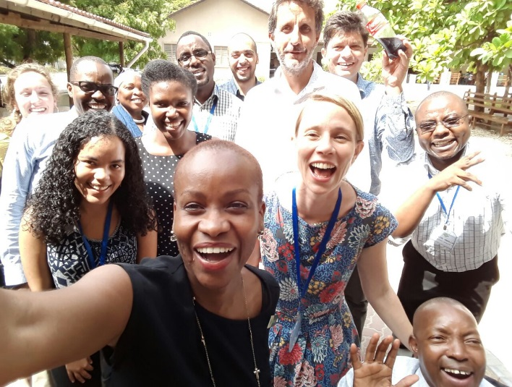
As any child growing up, and right through my early college years, I had an endless mental list of potential careers. It included popular choices like doctor, teacher and lawyer to more unique ones like dancer, astronaut, and scientist. After steadily distilling the list, I realized that I’m passionate about international development, and I graduated with the opportunity to work in the sector through a PiAf fellowship in Tanzania.
Meyris (first on left corner) with some of her colleagues
Fundraising and maintaining donor relations is necessary for most development organizations. I looked forward to using my fellowship to figure out whether this type of work would be right for me. Now, more than four months into my fellowship, I have more questions than answers: Do I really like this? Is this the type of work I see myself doing long-term?
As a Business Development Officer, I work with a small, but mighty team to fundraise for the organization and engage with donors. The work requires endless patience, flexibility, and the ability to have a good laugh with my team about how donor reports are going to drive us crazy.
Uncertainty has crept in sitting behind my desk fielding donor requests for data that takes me weeks to track down. Maybe it’s sitting behind a desk most of the day, the sometimes unrealistic donor expectations, or the instances of disorganization that NGOs face, but I’ll be honest and say that I’m confused (and that is okay!). The reality is that most development jobs require a lot of desk work, which is sometimes boring and repetitive. However, I know that desk work is just as important and impactful as “field work.” My team’s work allows thousands of Tanzanians to receive free treatment, covers the salaries of nurses and doctors, and supports outreach services across Tanzania.
So, when I’m down and frustrated with the stresses of my work, which inevitably causes me to doubt if this is The Job for me, I think about the many positives that keep me going every day. I’m in a privileged position to be working for a Tanzanian organization providing the best disability services in the country. I’m fortunate enough to work with a team who are passionate about the work we do and who make the hard days much more bearable. I’m also lucky to work right at the CCBRT Disability Hospital, giving me perspective on the patients we treat and helping me understand how the work I help produce translates into the services the organization provides to Tanzanians.
One lesson that I’ve learned and constantly remind myself of is that it’s okay to be confused and this fellowship year won’t answer all of my questions about the future. What I do know is that I see myself living, working, and growing in Africa for many years to come. For now, I’ll continue learning as much as I can from my post, enjoying my time in Tanzania, reflecting on where I see myself in the future, and how I can help change development practice and policy across Africa.

